PRODUCT INFORMATION
600 Series Plastic Wheel Caster
600**-******R-05
Wanda Industrial Plastic (Polyolefin) Wheels also known as Polyolefin Caster Wheels are injection molded from a blend of polyolefin/polypropylene polymers forming a one piece design that is solid and will not de-laminate. Polyolefin Wheels are great for wet and corrosive environments while providing a high impact resistant wheel. Polyolefin wheels are more economical compared to a Phenolic Wheel or a Steel Wheel. These wheels are non-marking and light in weight. Black is the standard color on plastic wheels.
Wheel  Dia.  D | Tread  Width  W | Load  Cap.  (kg) | Bearing  Options | Swivel  Radius  E | Overall  Height  H | Plate  Size  XxY | Setting  Pitch  X’xY’ | Hole  Dia.  P
100 | 50 | 230 | Roller | 31 | 141 | 115x100 | 83x71 | 11
125 | 50 | 300 | Roller | 41 | 163 | 115x100 | 83x71 | 11
150 | 50 | 320 | Roller | 44 | 189 | 115x100 | 83x71 | 11
200 | 50 | 400 | Roller | 44 | 239 | 115x100 | 83x71 | 11
*All dimention are “mm”.

Wheel  Dia.  D | Swivel Caster  Model No. | Fixed Caster  Model No. | Swivel  With Total Lock  Model No.
100 | 600PS-100050R-05 | 600PF-100050R-05 | 600PS-100050R-05-DUC
125 | 600PS-125050R-05 | 600PF-125050R-05 | 600PS-125050R-05-DUC
150 | 600PS-150050R-05 | 600PF-150050R-05 | 600PS-150050R-05-DUC
200 | 600PS-200050R-05 | 600PF-200050R-05 | 600PS-200050R-05-DUC
Wheel  Dia.  D | Swivel  With Side Brake  Model No. | Fixed  With Side Brake  Model No.
100 | 600PS-100050R-05-STC | 600PF-100050R-05-STC
125 | 600PS-125050R-05-STC | 600PF-125050R-05-STC
150 | 600PS-150050R-05-STC | 600PF-150050R-05-STC
200 | 600PS-200050R-05-STC | 600PF-200050R-05-STC
Advantages at a glance
Roll performance | l | l | l | l | ¡
Movement noise | l | l | l | ¡ | ¡
Attrition | l | l | l | ¡ | ¡
Corrosion resistance | l | l | l | l | ¡

Better Quality, Better Mobility.

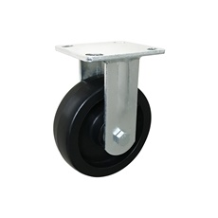
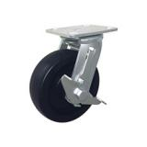
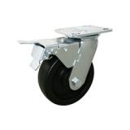
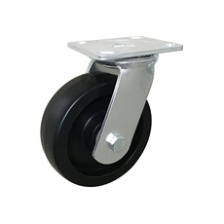
Picture may differ from original product

Dimensions
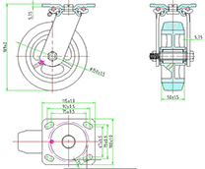

Stucture & Mounting
