PRODUCT INFORMATION
600 Series PU on Alu Wheel Caster
600**-******B-73
Wanda Polyurethane on Aluminium Caster with our High Quality Poly on Aluminum Wheels are used in many applications where the casters and wheels are exposed to water or chemicals. Aluminum is resistant to rust and provides a very strong core for the liquid cast polyurethane tread. Polyurethane on Aluminum wheels are used in Food Processing Equipment, Food Service, Hospitals, Research Laboratories, Pharmaceutical Laboratories, Bakeries, Schools, Institutional, and industrial applications and environments.
Wheel  Dia.  D | Tread  Width  W | Load  Cap.  (kg) | Bearing  Options | Swivel  Radius  E | Overall  Height  H | Plate  Size  XxY | Setting  Pitch  X’xY’ | Hole  Dia.  P
100 | 50 | 320 | Ball | 31 | 141 | 115x100 | 83x71 | 11
125 | 50 | 410 | Ball | 41 | 163 | 115x100 | 83x71 | 11
150 | 50 | 420 | Ball | 44 | 189 | 115x100 | 83x71 | 11
200 | 50 | 450 | Ball | 44 | 239 | 115x100 | 83x71 | 11
*All dimention are “mm”.

Wheel  Dia.  D | Swivel Caster  Model No. | Fixed Caster  Model No. | Swivel  With Total Lock  Model No.
100 | 600PS-100050B-73 | 600PF-100050B-73 | 600PS-100050B-73-DUC
125 | 600PS-125050B-73 | 600PF-125050B-73 | 600PS-125050B-73-DUC
150 | 600PS-150050B-73 | 600PF-150050B-73 | 600PS-150050B-73-DUC
200 | 600PS-200050B-73 | 600PF-200050B-73 | 600PS-200050B-73-DUC
Wheel  Dia.  D | Swivel  With Side Brake  Model No. | Fixed  With Side Brake  Model No.
100 | 600PS-100050B-73-STC | 600PF-100050B-73-STC
125 | 600PS-125050B-73-STC | 600PF-125050B-73-STC
150 | 600PS-150050B-73-STC | 600PF-150050B-73-STC
200 | 600PS-200050B-73-STC | 600PF-200050B-73-STC
Advantages at a glance
Roll performance | l | l | l | l | l
Movement noise | l | l | l | l | ¡
Attrition | l | l | l | l | ¡
Corrosion resistance | l | l | l | l | ¡

Better Quality, Better Mobility.

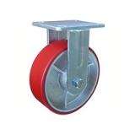
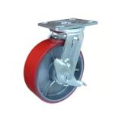
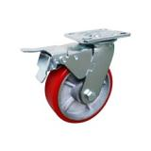
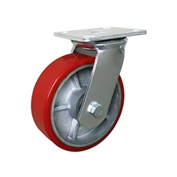
Picture may differ from original product

Dimensions
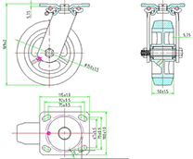

Stucture & Mounting
