PRODUCT INFORMATION
600 Series Cast Iron Wheel Caster
600**-******R-01
Wanda Cast Iron Casters also known as Gray Iron Casters are fully metal wheels and are less expensive than Ductile Wheels. Semi Steel wheels are better for light to medium duty applications if used on smooth concrete floors and applications where they do not take any type of overloading, impacts, or abuse.Temperature Range: -45℃ to +300℃, and Hardness: HBW 180

Wheel  Dia.  D | Tread  Width  W | Load  Cap.  (kg) | Bearing  Options | Swivel  Radius  E | Overall  Height  H | Plate  Size  XxY | Setting  Pitch  X’xY’ | Hole  Dia.  P
100 | 50 | 320 | Roller | 31 | 141 | 115x100 | 83x71 | 11
125 | 50 | 410 | Roller | 41 | 163 | 115x100 | 83x71 | 11
150 | 50 | 420 | Roller | 44 | 189 | 115x100 | 83x71 | 11
200 | 50 | 450 | Roller | 44 | 239 | 115x100 | 83x71 | 11
*All dimention are “mm”.

Wheel  Dia.  D | Swivel Caster  Model No. | Fixed Caster  Model No. | Swivel  With Total Lock  Model No.
100 | 600PS-100050R-01 | 600PF-100050R-01 | 600PS-100050R-01-DUC
125 | 600PS-125050R-01 | 600PF-125050R-01 | 600PS-125050R-01-DUC
150 | 600PS-150050R-01 | 600PF-150050R-01 | 600PS-150050R-01-DUC
200 | 600PS-200050R-01 | 600PF-200050R-01 | 600PS-200050R-01-DUC
Wheel  Dia.  D | Swivel  With Side Brake  Model No. | Fixed  With Side Brake  Model No.
100 | 600PS-100050R-01-STC | 600PF-100050R-01-STC
125 | 600PS-125050R-01-STC | 600PF-125050R-01-STC
150 | 600PS-150050R-01-STC | 600PF-150050R-01-STC
200 | 600PS-200050R-01-STC | 600PF-200050R-01-STC
Advantages at a glance
Roll performance | l | l | l | l | l
Movement noise | l | l | ¡ | ¡ | ¡
Attrition | l | l | l | l | l
Corrosion resistance | l | l | l | l | ¡

Better Quality, Better Mobility.

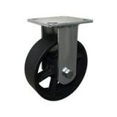
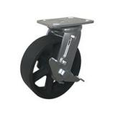
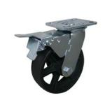
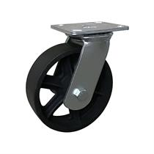
Picture may differ from original product

Dimensions
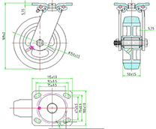

Stucture & Mounting
